1. Create a Particle System
2. The most difficult step to create a skill vfx is to create a ParticleSystem of Unity. In Hierarchy create a new GameObject, click “Add Component” in Inspector, and create a “ParticleSystem”. If you need some particle effects, you can edit this ParticleSystem. I’m also a newbie to that and you may search for tutorials online if you want to dig deeper. In this example I will only talk about adding a CG type vfx.

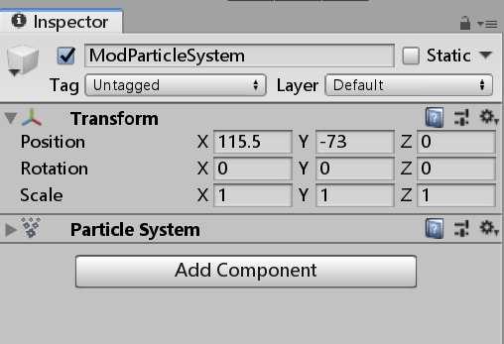

1. Create a Skill Particle

1. Click “Add Component” to create a “SkillParticle”, drag ParticleSystem to its “Main P” attribute.

“Hit Time” is a list of numbers representing the time when the camera will vibrate. At the last “Hit Time” the damage number will jump out.

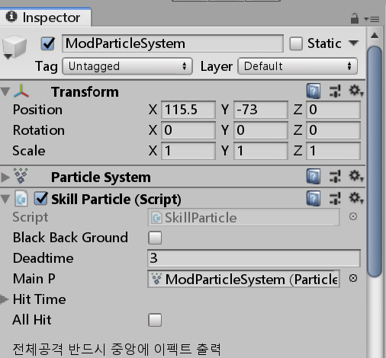

1. Create a Sound Effect

1. To add a sound effect, add a component “EventSounds”, expand “StartSound” and “SoundEvent”, then change “Size” to 1.

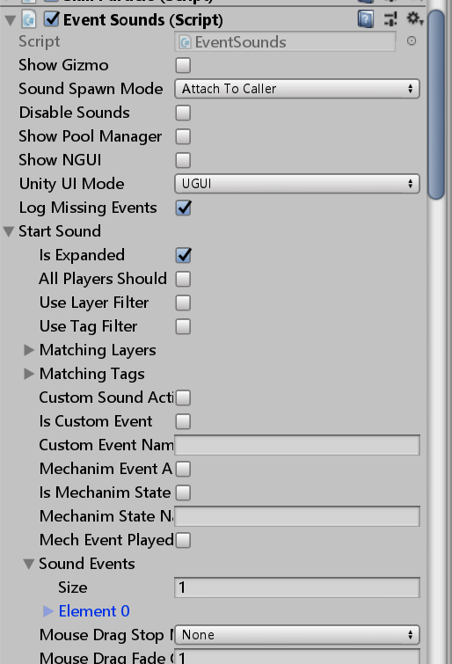

2. Apply the settings in the picture below. SoundType is the name of sound in your Mod Audio folder, or you can input a sound name in vanilla game. Set “Volume” to 1, “CurrentSoundGroupCommand” to “FadeToVolume”.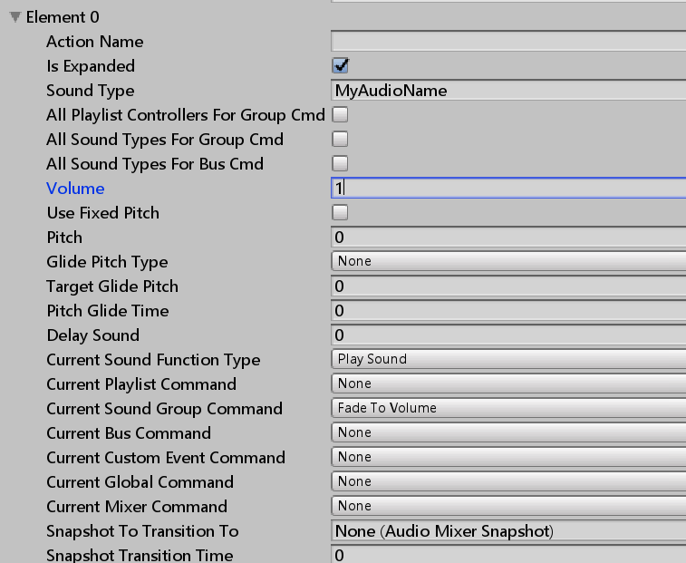

3. At the bottom of “SoundEvents”, check “UseStartSound”

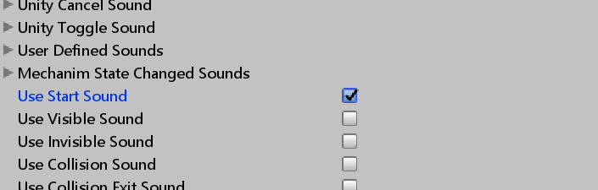

1. Create an Event CG

This is just an example of the simplest type of skill vfx, you may also create other types such as Animations using a similar method.

1. Prepare a png file, put it in your Unity project, then select the file and in Inspector set its “Texture Type” to “Sprite”.

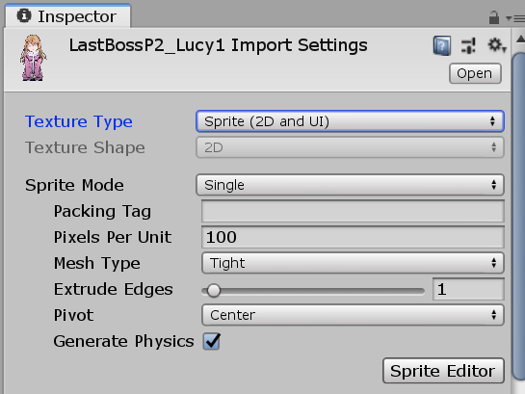

2. Create a new UI/Image as a child of your main GameObject. Choose your prepared image as the sprite in Inspector. Change its layer to “Lock”.

3. Create a new Camera as a child of your main GameObject and change its layer to “Lock”. I don’t understand this part, but it seems a camera is needed for a CG type vfx, otherwise the image cannot show properly (other type of vfx may not need it). Adjust the position of the Image so that the camera shows the CG properly.

4. For CG type vfx you may not need an active ParticleSystem, you can uncheck its attributes.

5. Adjust the attributes of the SkillParticle you created earlier. The important attributes are:

* Deadtime - duration of your CG
* Is Spacial CG – check it
* Use Custom UI Remove / Custom UI Remove - check them
* Spacial CG_Hide Enemy – check it

You may explore other attributes by yourself.

Once a skill vfx is finished, drag the main GameObject to the folder to create a prefab which is ready to be exported.